CYBERQUOTE PTE LTD

Sales Performance Management
Phase III

Program Design Specification
- Contact Analysis

For: | CYBERQUOTE PTE LTD | Project Ref: | PM1001
Author: | Thet Su Mon | Doc Ref: | SpmPhaseIII-TS-PS-Contact Analysis -1.0
Proj Mgr: | Ei Ei Thu | Version:
Date: | 19/10/2011 | Classification:
To : |  | Cc:

Document Revision History

Document Title :

Version | Revised by | Effective Date | Summary of Change | Reason for change
1.0 | Thet Su | 19/10/2011 | New Document | -

Table of Contents

1 Program Definition 3
1.1 System Name 3
1.2 Program Description 3
1.3 Programming Language/Version 3
1.4 Drivers Required/Version 3
2 Structure Design 3
2.1 Block Chart or Flow Chart on top level structure of the program 3
2.1.1 Presentation Layer 3
2.1.2 Web Service Layer 4
2.2 Description of each module 5
2.2.1 Presentation Layer 5
2.2.2 WebService Layer 6
2.3 Description of Stored Procedures used 7
3 Input/Output files used 7
3.1 Input/Output file format design (with Samples attached) 7
3.2 Database connections used 7
4 Error Message/Warning Message List 7
5 Program List 7
6 Acceptance Form 8

Program Definition

System Name
Sales Performance Management (hereinafter referred as SPM) system Phase III

Program Description
This is the program design specification of “Contact Analysis” function which is defined under “Contact Analysis” in the design specification.

Programming Language/Version
This program will be developed in C# using Visual Studio 2008 for running under ASP.net 3.5.

Drivers Required/Version
The ASP.NET AJAX 1.0 is required to support Ajax in ASP.NET environment.

Structure Design

Block Chart or Flow Chart on top level structure of the program

Presentation Layer

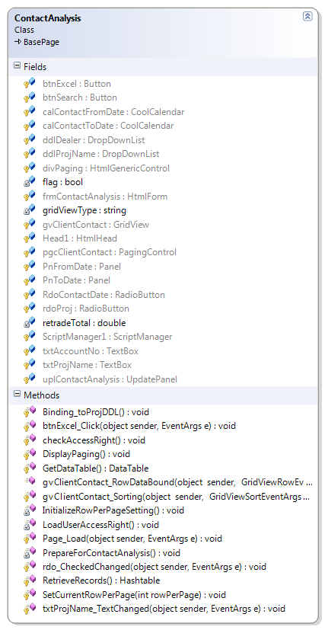

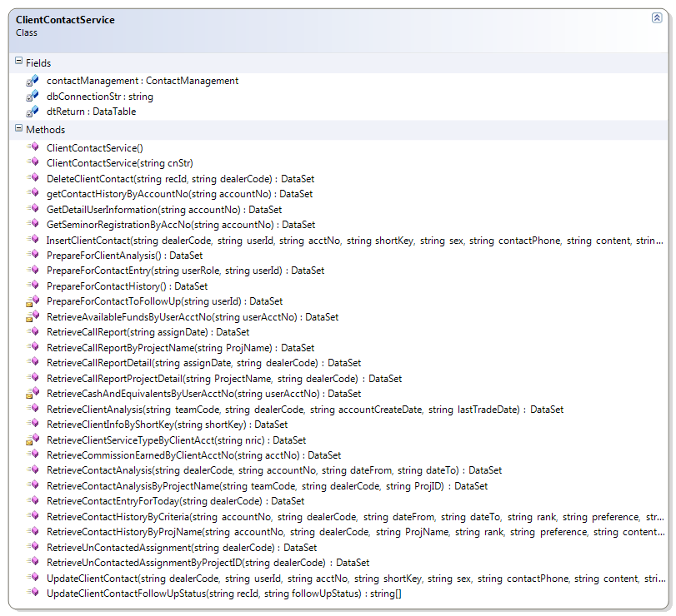

Web Service Layer

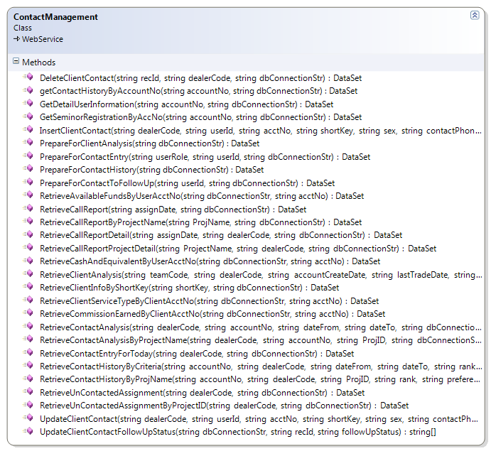
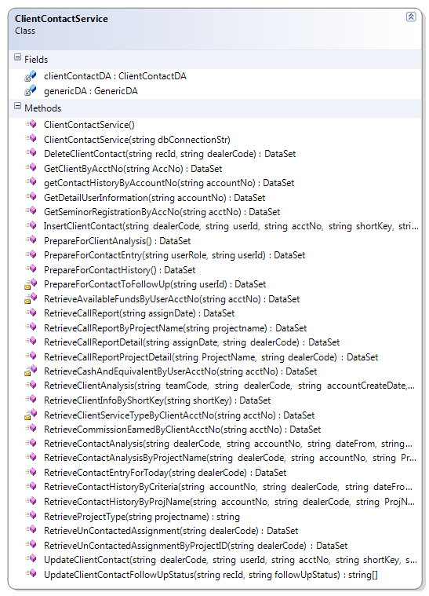
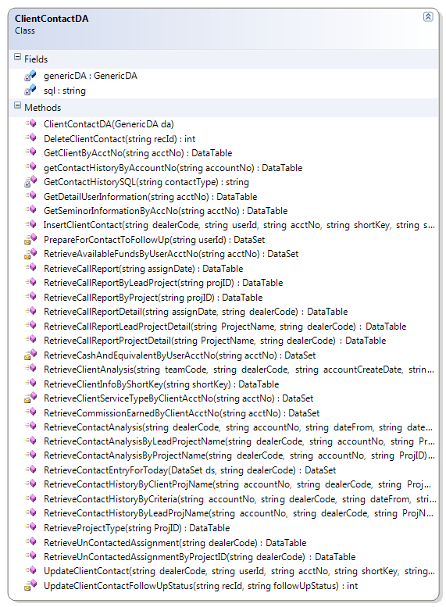

Description of each module

Presentation Layer

ContactAnalysis.aspx.cs
Member | Description
Fields
clientContactService | Control for accessing web service layer
gridViewType | To use for generating excel report.
retradeTotal | Total client re-trade amount
Flag | To define the drop down list binding or not.
Methods
Page_Load | Retrieve and construct user dropdown list
PrepareForContactAnalysis | Set Assign Date From value to one week from current date and Assign Date to value to current date. Retrieve and construct dealers dropdownlist.
RetrieveRecords | Retieve call report for user selected assign date by calling clientContactServiceRetrieveContactAnalysis() method;  Construct gridview to show client contact analysis records.
InitializeRowPerPageSetting | Set default values for paging user control.
DisplayPaging | Use to display paging user control after client contact records is retrieved from database.
SetCurrentRowPerPage | Call from BasePage class to store current row per page in viewstate for paging control whenever user change the value.
GetDataTable | Call from BasePage class to get data to display whenever user change the page no (or) row per page.
checkAccessRight | Check the access right and enable or disable the button according to the access right.
LoadUserAccessRight | Retrieve the User access right.
Binding_toProjDDL | Retrieve assignment project name for users to use in search the assigned client info.
txtProjName_TextChanged | Retrieve the project name by calling Binding_toProjDDl method;
Rdo_CheckedChanged | To enable or disable the calendar or drop down list.
btnExcel_Click | Generate excel file for retrieved client contact records.
gvClientContact_RowDataBound | Calculate total client re-trade and display re-trade record as brown color.
gvClientContact_Sorting | Sort client contact records.

ClientContactService.cs
Member | Description
Fields
dbConnectionStr | Database connection string
contactManagement | Reference of the assignment management web service
dtReturn | Return Data table
Methods
ClientContactService | Constructor: to create contact management web service instance
ClientContactService(string cnStr) | Constructor: get database connection from caller after ClientContactService() constructor
RetrieveContactAnalysis | Retrieve client contact analysis records for user entered search criteria with the assigned date.
RetrieveContactAnalysisByProjectName | Retrieve client contact analysis records for user entered search criteria with the project name.

WebService Layer

ContactManagementService.asmx.cs
Member | Description
Methods
RetrieveContactAnalysis | Retrieve client contact analysis records for user entered search criteria.
RetrieveContactAnalysisByProjectName | Retrieve client contact analysis records for user entered search criteria with the project

ClientContactService.cs
Member | Description
Fields
clientContactDA | Data access layer for client assignment services
dtReturn | Return datatable
GenericDA | Generic data access layer
returnCode | Return Code  1 – Successful  -1 – Failed
returnMessage | Return message
Methods
ClientContactService | Constructor: to create generic data access and client assignment data access instance
ClientContactService(string cnStr) | Constructor: get database connection from caller after ClientContactService() constructor
RetrieveContactAnalysis | Retrieve client contact analysis records for user entered search criteria.
RetrieveContactAnalysisByProjectName | Retrieve client contact analysis records for user entered search criteria with the project.
RetrieveProjectType | To retrieve the project type.

ClientContactDA.cs
Member | Description
Fields
GenericDA | Generic data access layer
sql | Sql statements
Methods
RetrieveContactAnalysis | Retrieve client contact analysis records for user entered search criteria with the assigned date.
RetrieveContactAnalysisByProjectName | Retrieve client contact analysis records for user entered search criteria and client project name.
RetrieveContactAnalysisByLeadProjectName | Retrieve client contact analysis records for user entered search criteria and lead project name.
RetrieveProjectType | To retrieve the project type.

Description of Stored Procedures used
None

Input/Output files used
None

Input/Output file format design (with Samples attached)
N/A

Database connections used
BasePage.dbConnectionStr

Error Message/Warning Message List
Message | Cause
Contact Analysis not found! | No matched record is found for user entered search criteria.
Error in retrieving contact analysis report! Please try again. | When system failed to retrieve call report records.
Problem in WebService Connection! | When system failed to call web service
Please retrieve Assignments/Projects first before searching Call Report. | User doesn’t select the Assignment date or project name then clicking the search button.
No records to generate Excel File! | When user click the excel button, no records to generate.

Program List
SPMWebApp\Services
ClientContactService.cs

SPMWebApp\WebPages\ContactManagement
ContactAnalysis.aspx
ContactAnalysis.aspx.cs
ContactAnalysis.aspx.designer.cs

SPMWebServiceApp\WebServices
ContactManagement.asmx
ContactManagement.asmx.cs

SPMWebServiceApp\Services
ClientContactService.cs

SPMWebServiceApp\DataAccess
ClientContactDA.cs

Acceptance Form

Project Name : | Sales Performance Management Phase II
Document Name : | Program Design Specification – Contact Analysis  (Doc Ref: SpmPhaseII-TS-PS-Contact Analysis-1.0)
Company Name : | CyberQuote Pte Ltd
Project Manager : | Li Qun
Designation : | Snr Consultant
Signature/Date :

